**Behavior Development Driven**

**On Robot Framework IDE**

Feature 1: Candidate

* Add
  + (+) Success adding candidate:
    - Given I login into Orange HR
    - When I navigate to Candidate and click Add
    - And I fill the information
    - Then I save the information
  + (-) Left blank
    - Given I login into Orange HR
    - When I navigate to Candidate and click Add
    - And I do not fill the information
    - Then I got require error
  + (-) Wrong email format
    - Given I login into Orange HR
    - When I navigate to Candidate and click Add
    - And I do not fill the information
    - Then I got require error
  + (-) Upload file exceed
    - Given I login into Orange HR
    - When I navigate to Candidate and click Add
    - And I fill the information but resume size is exceed
    - Then I got exceed error
* Delete
  + (+) Success deleting candidate:
    - Given I login into Orange HR
    - When I navigate to Candidate and click Add
    - And I search candidate and click delete
    - Then I get successful delete

Positive: Successful Adding Candidates

Scenarios:

Given I login into OrangeHR

When I navigate to candidate section and add candidate

And I fill the information

Then I save the information

Step 1: Create Step Definition

1. Create new directory/folder (optional) for saving step definitions: Right click on main directory (on left side of RIDE) and choose ‘New Suit’.
2. In Add Suit window, change Type from ‘File’ into ‘Directory’. Then click ‘OK’. ‘Step Definition’ directory can be found under main directory

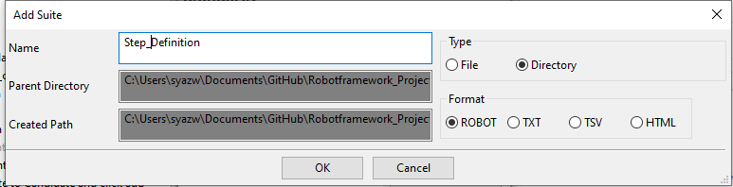

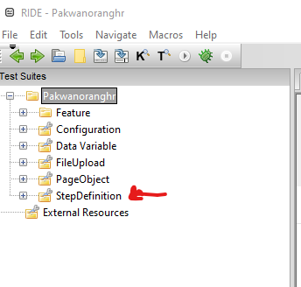

1. Create scenarios resource by right click on step definition folder and click ‘New Resource’.
2. ‘New resource file’ window will be popped up. Give a name and click ‘OK’.
3. Click on that scenarios resource file, then add Selenium Library
4. To create scenario (BDD), click on tab Text Edit.
5. Type *** Keywords *** and the next line write all scenarios as shown in below:

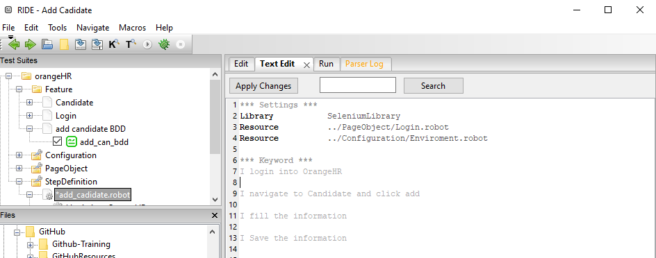

1. As your notice, there 4 files (which are keyword files) are created under scenarios resource file as shown in figure below:

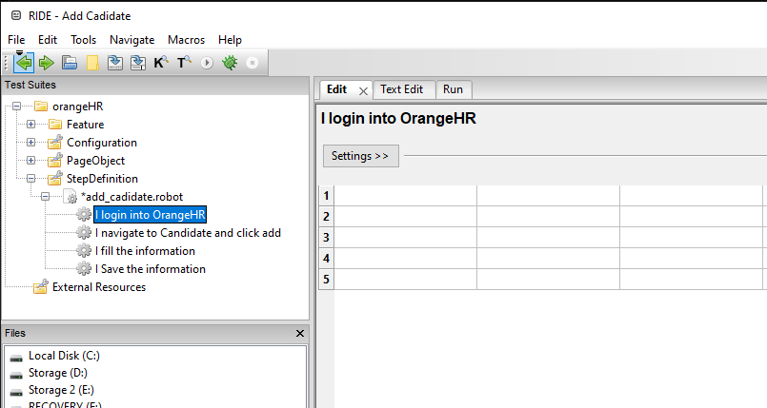

1. Add selenium component (steps), xpath and value into scenario file as shown in below:

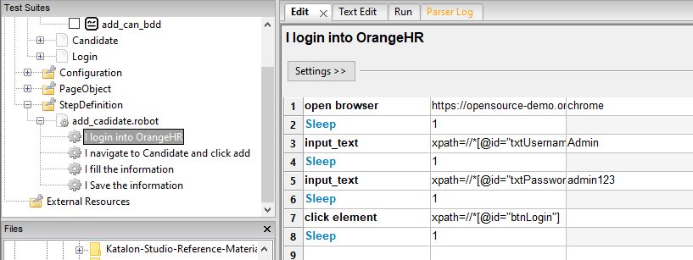

1. Set test cases in all scenarios.

Step 2: Create BDD

1. Create text suit for BDD under main directory. Then, add SeleniumLibrary and click ‘Resource’ as shown in below:

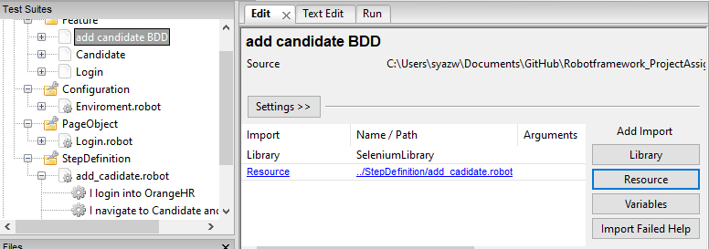

1. ‘Resource’ window will be popped up. Browse scenario resource file as shown in below and click OK.

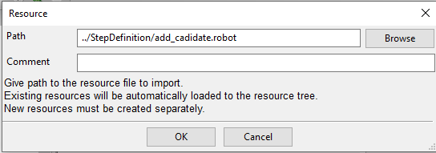

1. The list of added library and resource is shown. If library and resource are invalid, colour of library and resource word become red.

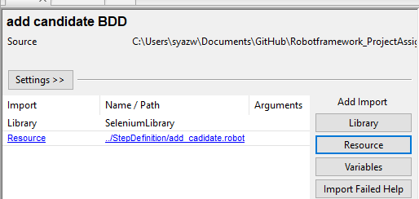

1. After that, create test case under BDD test suit and then click it.
2. Write down scenarios into table in Edit tab (include Given, When, And, and Then) as shown in below:

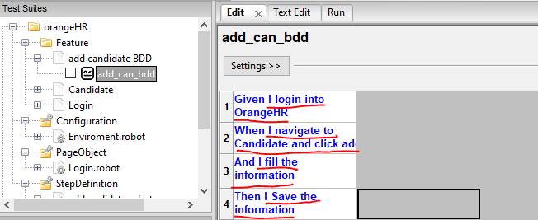

1. Finally, go to Run tab. Next, tick a box on test case and then click Start

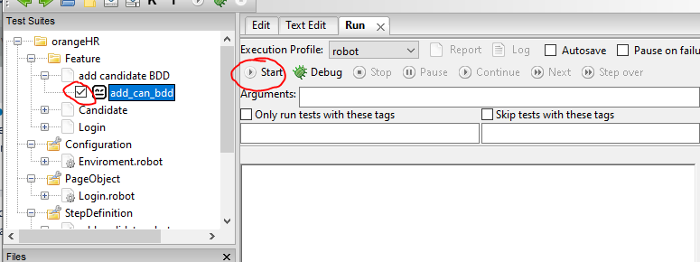

**Feature 2: Job**

* Add
  + (+) Success adding job
    - Given I login into OrangeHRM
    - When I navigate to job categories and click add job categories
    - And I fill the information
    - Then I save the information
* Delete
  + (+) Success deleting job
    - Given I login into OrangeHRM
    - When I navigate to job categories and click check box
    - And I click delete
    - Then I click ok

**Feature 3: License**

* Add
  + (+) Successfully add new license
    - Given Login into OrangeHR
    - When Navigate to License
    - When click Add
    - And Fill the information 1
    - Then Save the information
  + (-) User enter the same license
    - Given Login into OrangeHR
    - When Navigate to License
    - When click Add
    - And Fill the information 1
    - Then Save the information
  + (-) User did not enter any license name
    - Given Login into OrangeHR
    - When Navigate to License
    - When click Add
    - And Did not fill information
    - Then Error label will appear
* Delete
  + (+) Successfully delete a license
    - Given Login into OrangeHR
    - When Navigate to License
    - And Select checkbox
    - Then Click Delete
  + (+) Successfully delete more than one license
    - Given Login into OrangeHR
    - When Navigate to License
    - And Select more than one checkbox
    - Then Click Delete

STEP 1: Create StepDefinition directory folder:

1. Create new project
2. Right-click on the project and choose new suite. Select the type as ‘Directory’ and format ‘ROBOT’.
3. Name the file as ‘StepDefinition’ then click OK.

STEP 2: Create Step Definition directory folder:

1. Right-click on the StepDefinition file and choose new resource. Name the file. Eg: Add_license.robot
2. Choose format ‘ROBOT’. Then click ‘OK’

STEP 3:  Import library & resources

1. Click on the ‘add_license.robot@ resources file
2. Click edit. Then click on ‘Library’ on the right-side.
3. Browse and choose your Selenium library folder.
4. Click ‘OK’
5. Click ‘Resources’ to add other resources file

STEP 4: Create user keyword

There is two ways two create user-keyword

1. Tab ‘Edit’
2. Tab ‘Text Edit’

STEP 4.1: Create user keyword (Tab ‘edit’)

1. Right-click on resource file eg: add_license.robot
2. Select new user keyword
3. Enter new user keyword and click ‘OK’

1. Write steps, xpath and value into scenario file as shown in below:
2. Then, save the file.

STEP 4.2: Create user keyword (Tab ‘Text edit’)

1. Directly click on ‘Text Edit’ Tab
2. Write steps, xpath and value into scenario file as shown in below:
3. Then save the file

STEP 5: Create new suite for BDD

1. Right-clcik on feature folder and choose new suite
2. Name the bdd file eg: add_license_bdd
3. Choose type ‘File’ and format ‘ROBOT’ then click ‘OK’

STEP 6: Create new test case

1. Right-click on bdd file and choose new test case.
2. Name the tase case. Eg: add_new_license
3. Click ‘OK’

STEP 7: Import library and resources

1. Click on library and import Selenium Library
2. Click on resources and import your resources file
3. Then, click ‘OK’

STEP 8 : Write scenarios

1. You can write and edit your scenarios through ‘Edit’ tab
2. If the colour turn out ‘blue’ means the scenarios written are valid from your resources file.

STEP 9: Write scenarios

1. You can also write and edit your scenarios through ‘Text Edit’ tab

STEP 10: Run test case

1. Tick the test case you want to run.
2. Go to ‘Run’ tab
3. Click ‘Start’ robot button.

STEP 11: Test case report

1. Click report button on ‘Run’ tab to check the report